Test Case: tc001_SPX_Dev5_Crear_Requisicion_Spot_Tipo_Cobro_CC
Step 1 - Enter username and password and click to button Enter : Credentials Entered
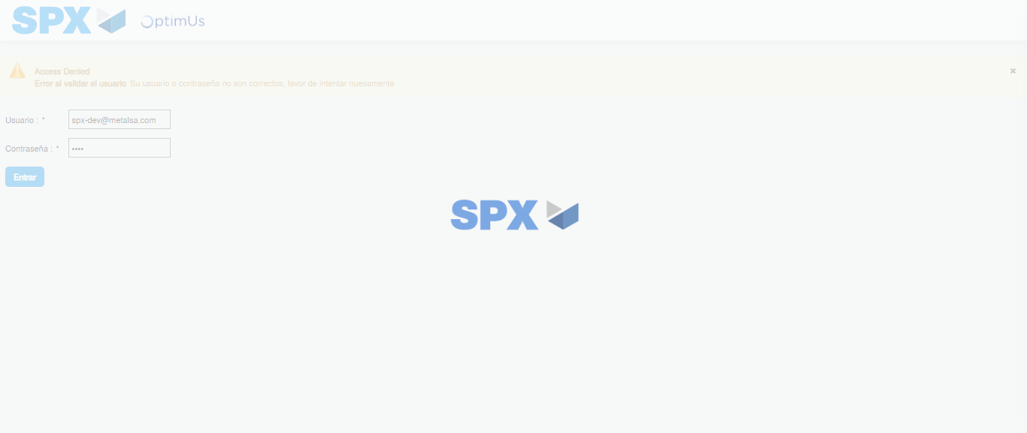Image file-name: QC_Testing-tc001_SPX_Dev5_Crear_Requisicion_Spot_Tipo_Cobro_CC-1782164990656

Step 2 - Select to UEN and Access to Spot Buy Requisitions : UEN Correctly selected and Correct access
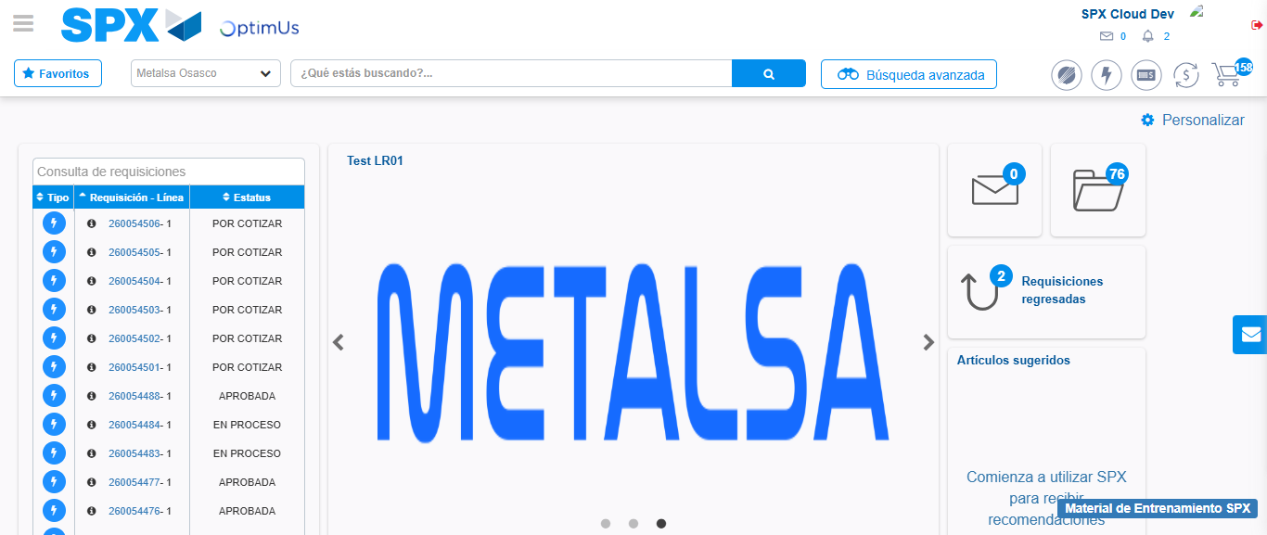Image file-name: QC_Testing-tc001_SPX_Dev5_Crear_Requisicion_Spot_Tipo_Cobro_CC-1782165017254

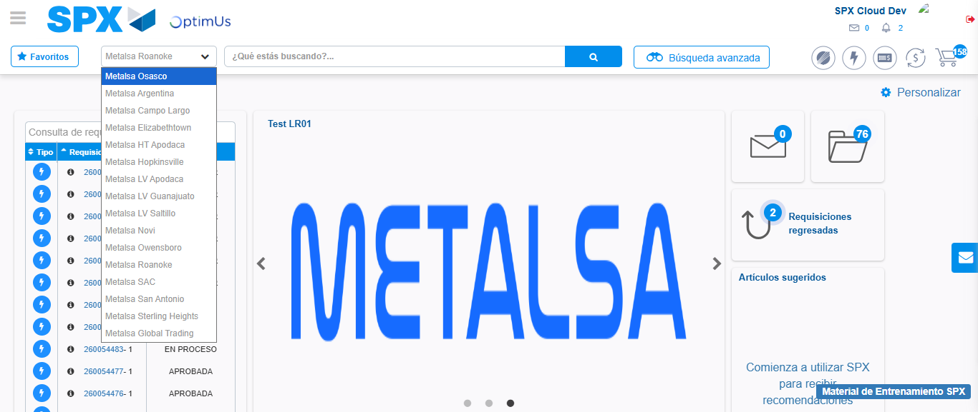Image file-name: QC_Testing-tc001_SPX_Dev5_Crear_Requisicion_Spot_Tipo_Cobro_CC-1782165019802

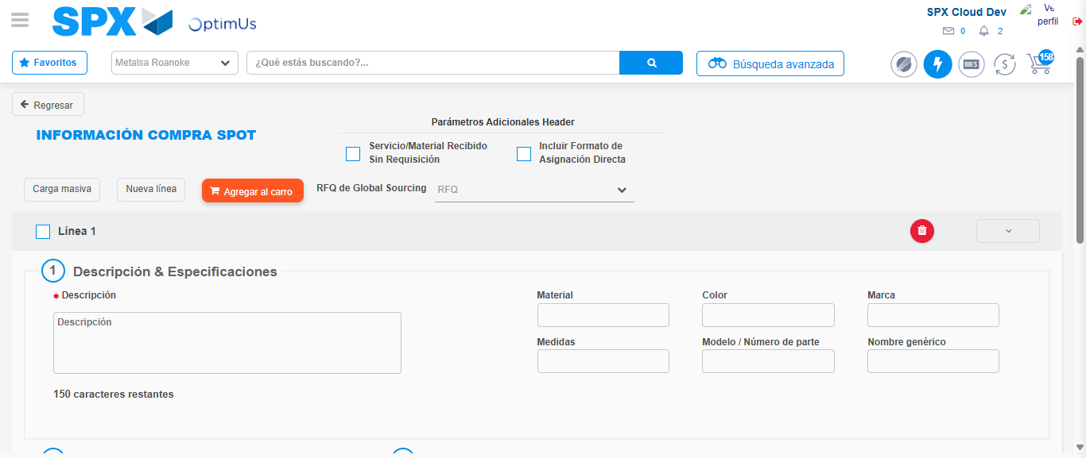Image file-name: QC_Testing-tc001_SPX_Dev5_Crear_Requisicion_Spot_Tipo_Cobro_CC-1782165042295

Step 3 - Data Capture Spot Buy Requisition : Data captured correctly
Image file-name: QC_Testing-tc001_SPX_Dev5_Crear_Requisicion_Spot_Tipo_Cobro_CC-1782165042511

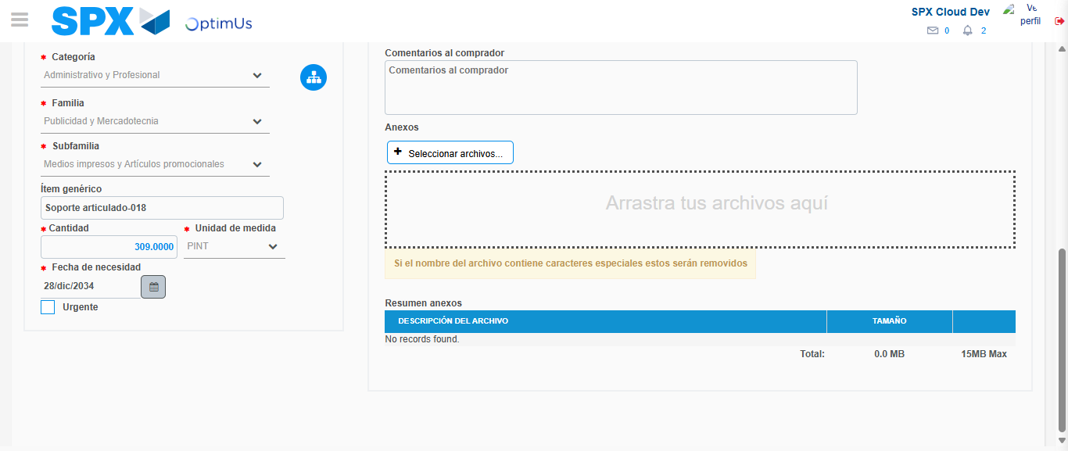Image file-name: QC_Testing-tc001_SPX_Dev5_Crear_Requisicion_Spot_Tipo_Cobro_CC-1782165053817

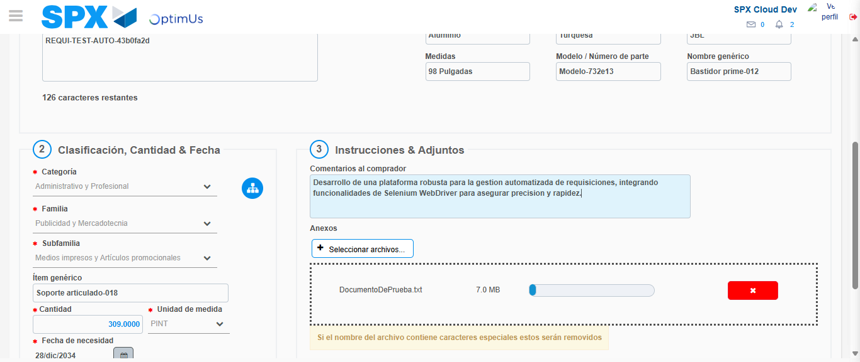Image file-name: QC_Testing-tc001_SPX_Dev5_Crear_Requisicion_Spot_Tipo_Cobro_CC-1782165054601

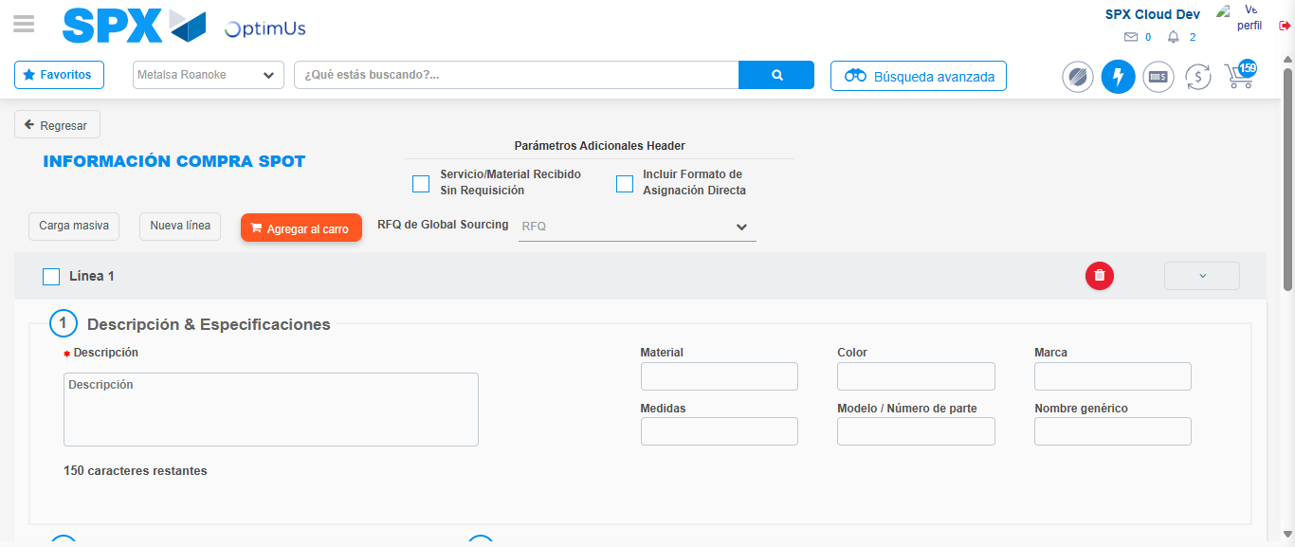Image file-name: QC_Testing-tc001_SPX_Dev5_Crear_Requisicion_Spot_Tipo_Cobro_CC-1782165060156

Step 4 - Select to Requisition : Requisition Correctly selected
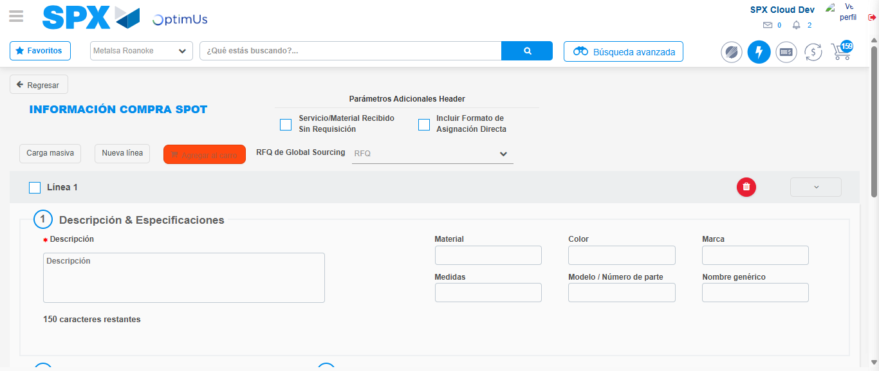Image file-name: QC_Testing-tc001_SPX_Dev5_Crear_Requisicion_Spot_Tipo_Cobro_CC-1782165060417

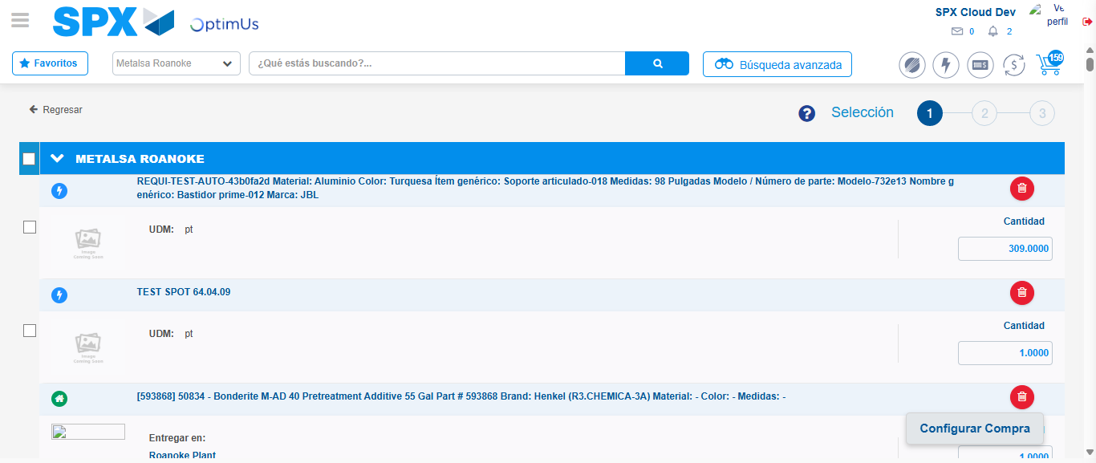Image file-name: QC_Testing-tc001_SPX_Dev5_Crear_Requisicion_Spot_Tipo_Cobro_CC-1782165116070

Image file-name: QC_Testing-tc001_SPX_Dev5_Crear_Requisicion_Spot_Tipo_Cobro_CC-1782165116331

Image file-name: QC_Testing-tc001_SPX_Dev5_Crear_Requisicion_Spot_Tipo_Cobro_CC-1782165116532

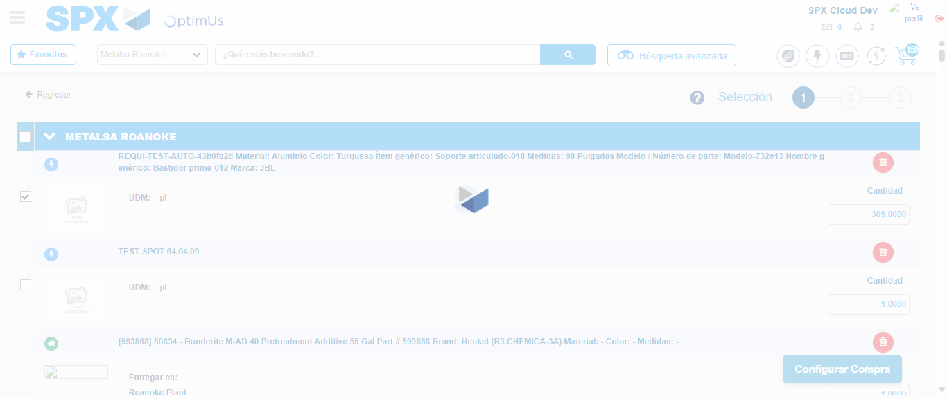Image file-name: QC_Testing-tc001_SPX_Dev5_Crear_Requisicion_Spot_Tipo_Cobro_CC-1782165118450

Step 5 - Select Type Account For Requisition : Type Account Correctly selected
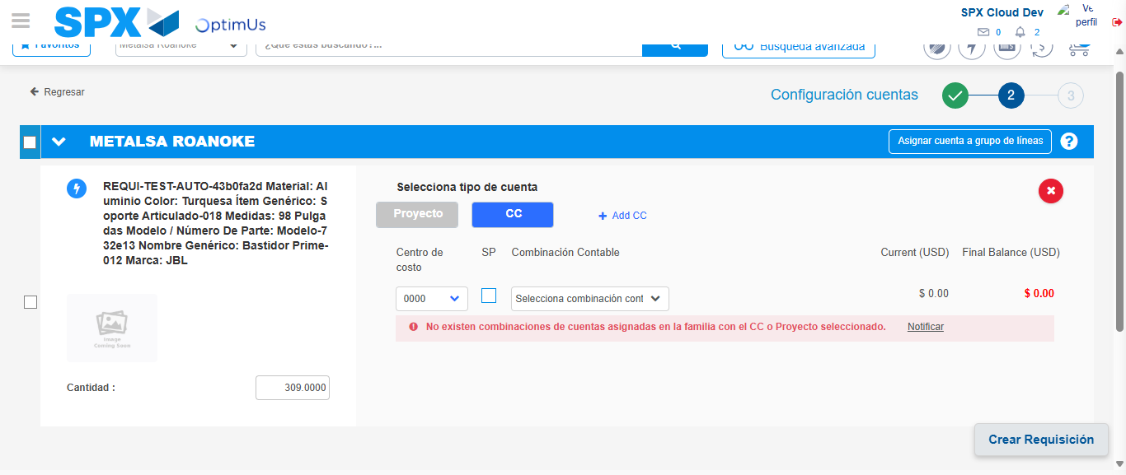Image file-name: QC_Testing-tc001_SPX_Dev5_Crear_Requisicion_Spot_Tipo_Cobro_CC-1782165134441

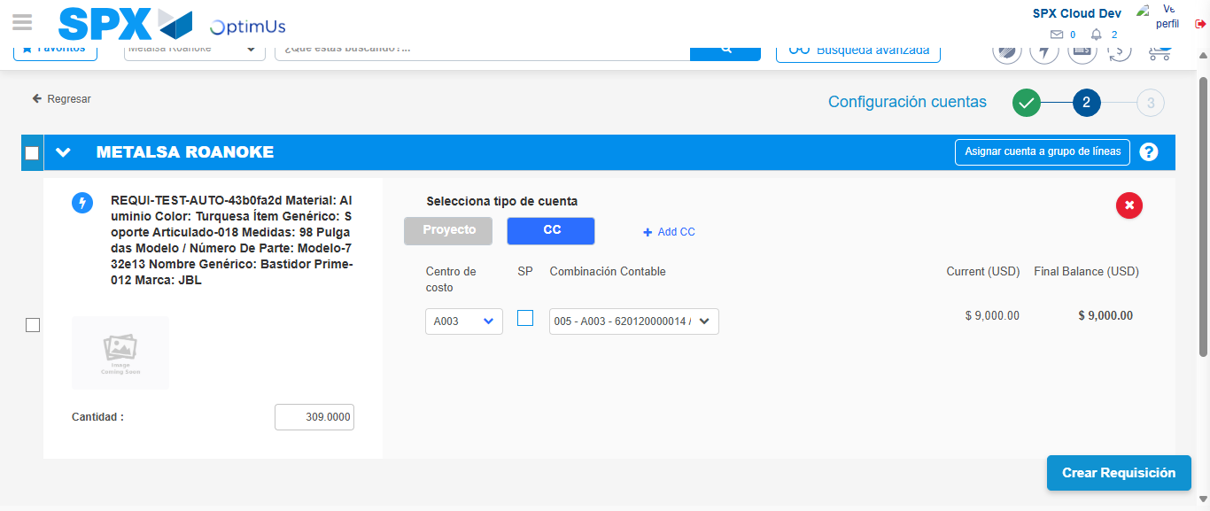Image file-name: QC_Testing-tc001_SPX_Dev5_Crear_Requisicion_Spot_Tipo_Cobro_CC-1782165142880

Image file-name: QC_Testing-tc001_SPX_Dev5_Crear_Requisicion_Spot_Tipo_Cobro_CC-1782165143057

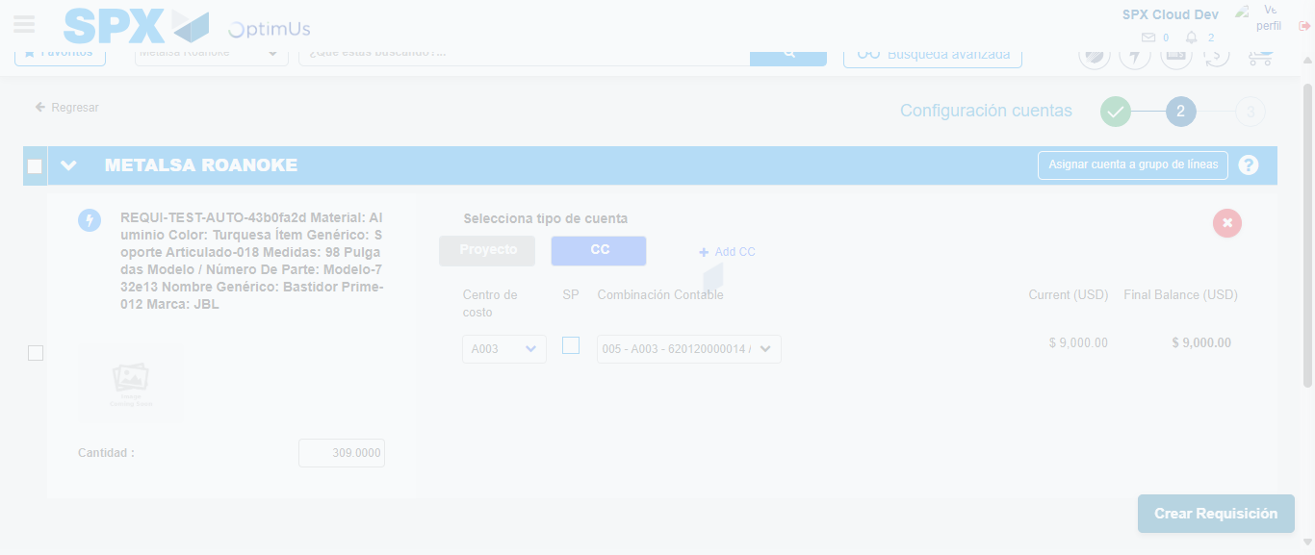Image file-name: QC_Testing-tc001_SPX_Dev5_Crear_Requisicion_Spot_Tipo_Cobro_CC-1782165143443

Step 6 - Accept to Requisition : Requisition Accepted
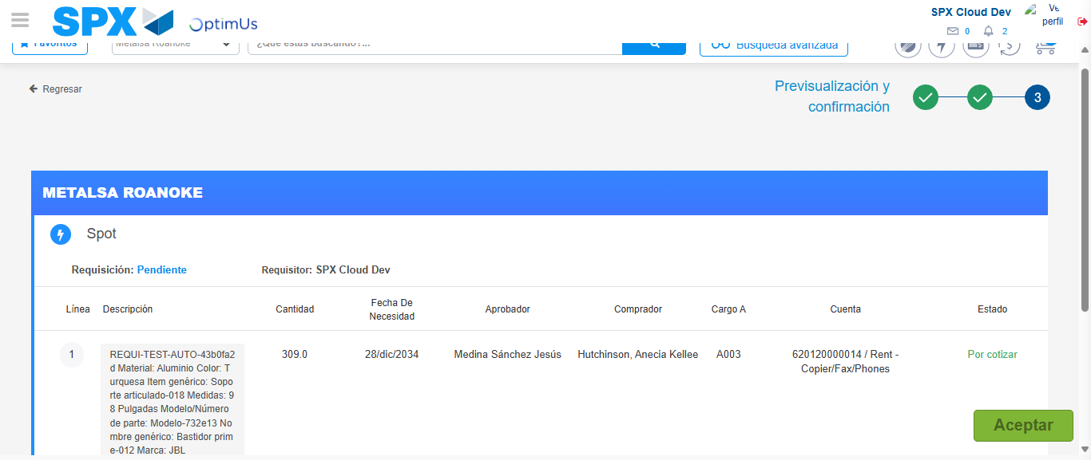Image file-name: QC_Testing-tc001_SPX_Dev5_Crear_Requisicion_Spot_Tipo_Cobro_CC-1782165144704

Image file-name: QC_Testing-tc001_SPX_Dev5_Crear_Requisicion_Spot_Tipo_Cobro_CC-1782165144873

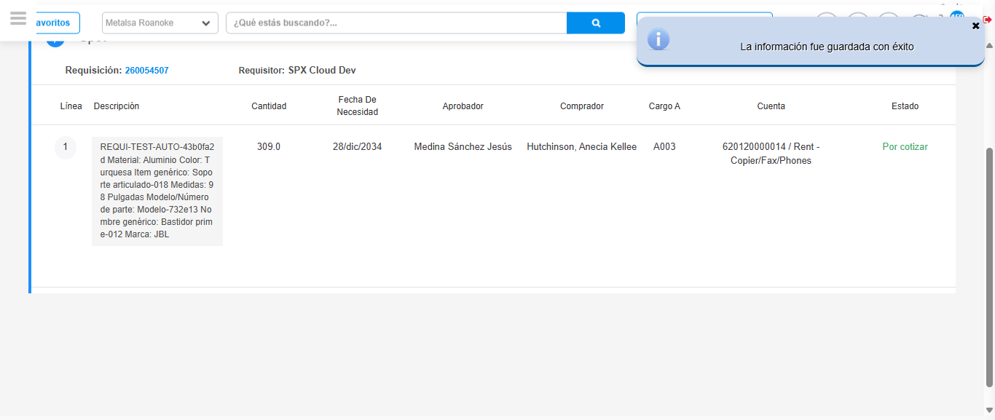Image file-name: QC_Testing-tc001_SPX_Dev5_Crear_Requisicion_Spot_Tipo_Cobro_CC-1782165147808

Step 7 - Return to Main Page SPX : Return to Main Page SPX
Image file-name: QC_Testing-tc001_SPX_Dev5_Crear_Requisicion_Spot_Tipo_Cobro_CC-1782165017254

Image file-name: QC_Testing-tc001_SPX_Dev5_Crear_Requisicion_Spot_Tipo_Cobro_CC-1782165019802

Image file-name: QC_Testing-tc001_SPX_Dev5_Crear_Requisicion_Spot_Tipo_Cobro_CC-1782165042295

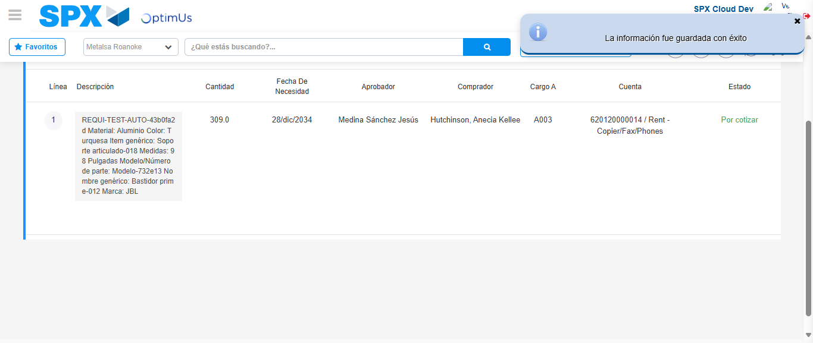Image file-name: QC_Testing-tc001_SPX_Dev5_Crear_Requisicion_Spot_Tipo_Cobro_CC-1782165150044

Image file-name: QC_Testing-tc001_SPX_Dev5_Crear_Requisicion_Spot_Tipo_Cobro_CC-1782165150189

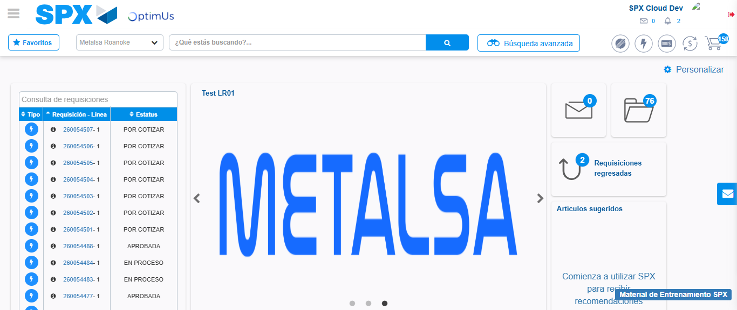Image file-name: QC_Testing-tc001_SPX_Dev5_Crear_Requisicion_Spot_Tipo_Cobro_CC-1782165171241

Step 8 - Log Out : Log Out SPX
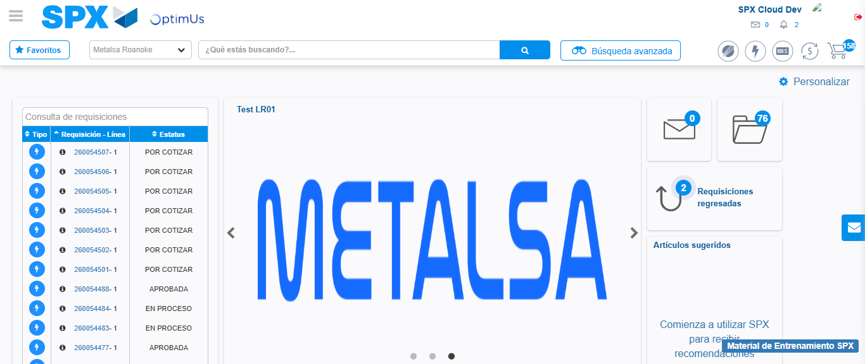Image file-name: QC_Testing-tc001_SPX_Dev5_Crear_Requisicion_Spot_Tipo_Cobro_CC-1782165171526

